**Assignment 12.3**

Creating a list of tuples, where the 1st element of the tuple is an int and the second element is a string:

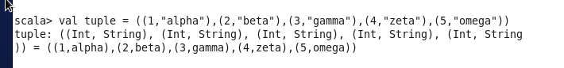

List of tuples is created.